# Project Report: Personal Portfolio Website

This report provides a detailed overview of the Personal Portfolio Website project, covering objectives, requirements, design, implementation, and outcomes.

## Objective

The objective of this project is to create a personal portfolio website to showcase skills, projects, and resume. It provides hands-on practice with HTML for structuring web content, CSS for styling, and JavaScript for interactivity.

## Requirements

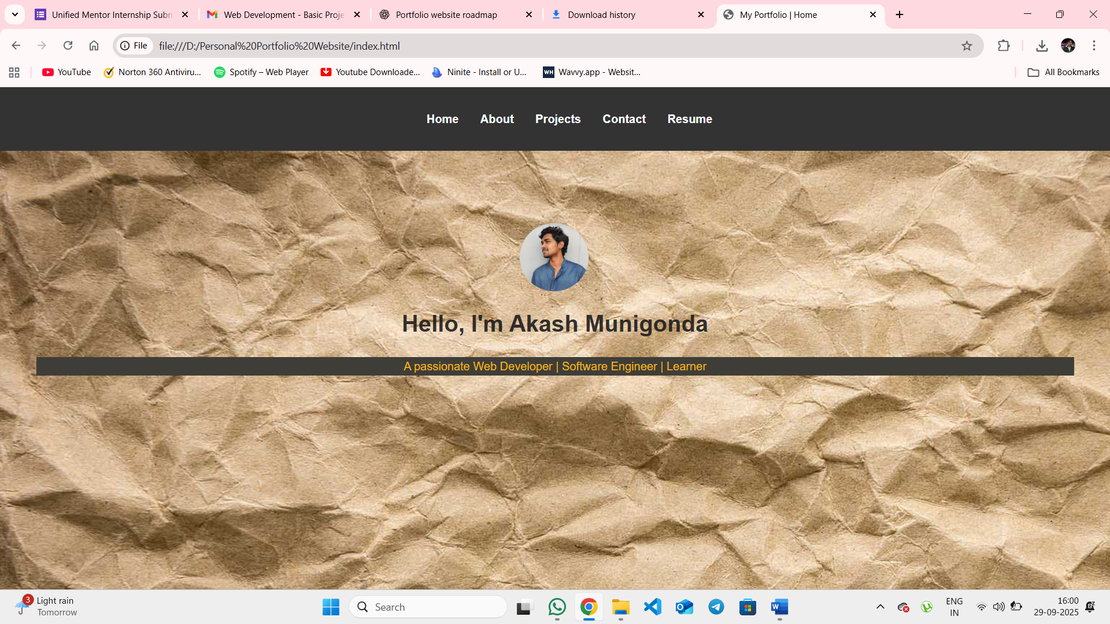

Home Page: Includes name, bio, profile picture, and navigation links.

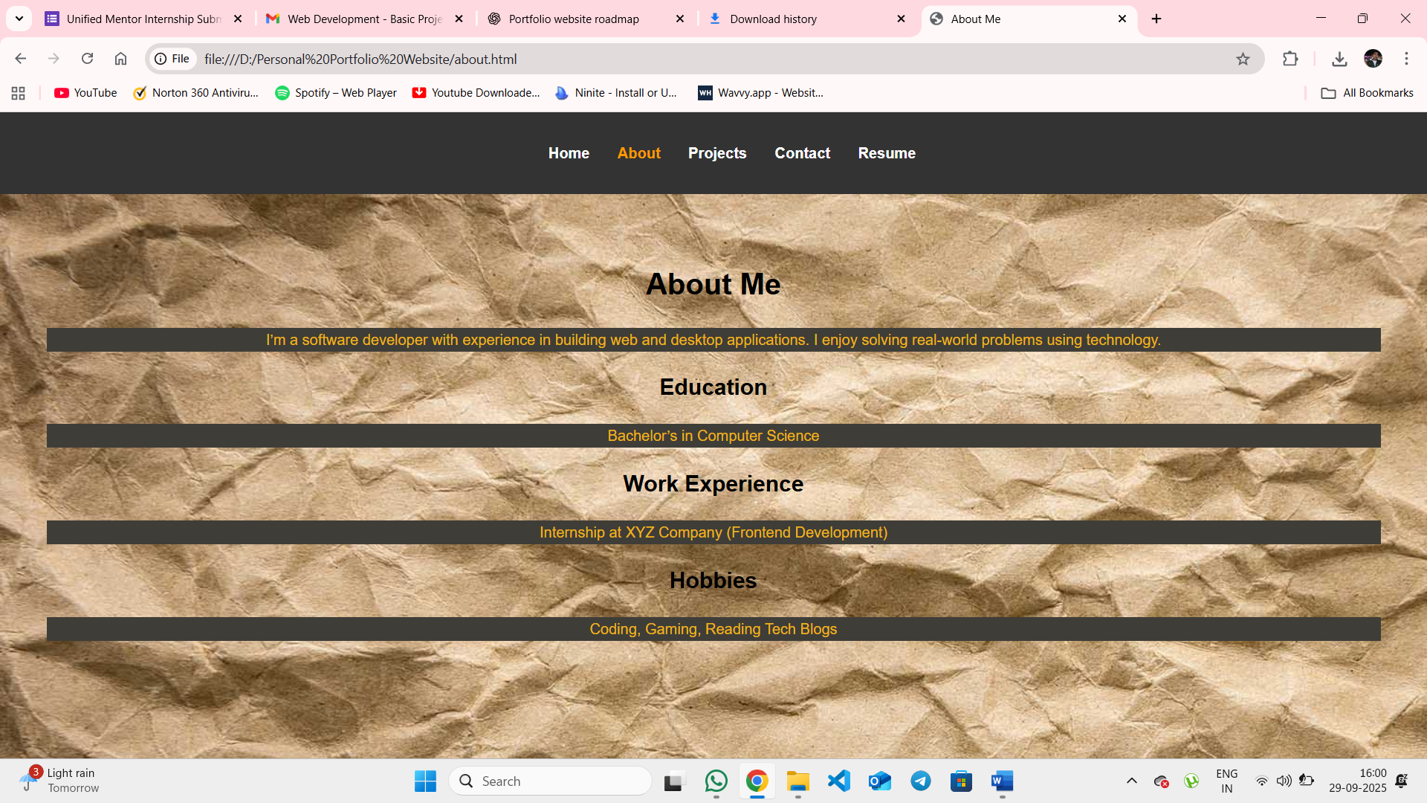

About Page: Provides details about education, experience, and hobbies.

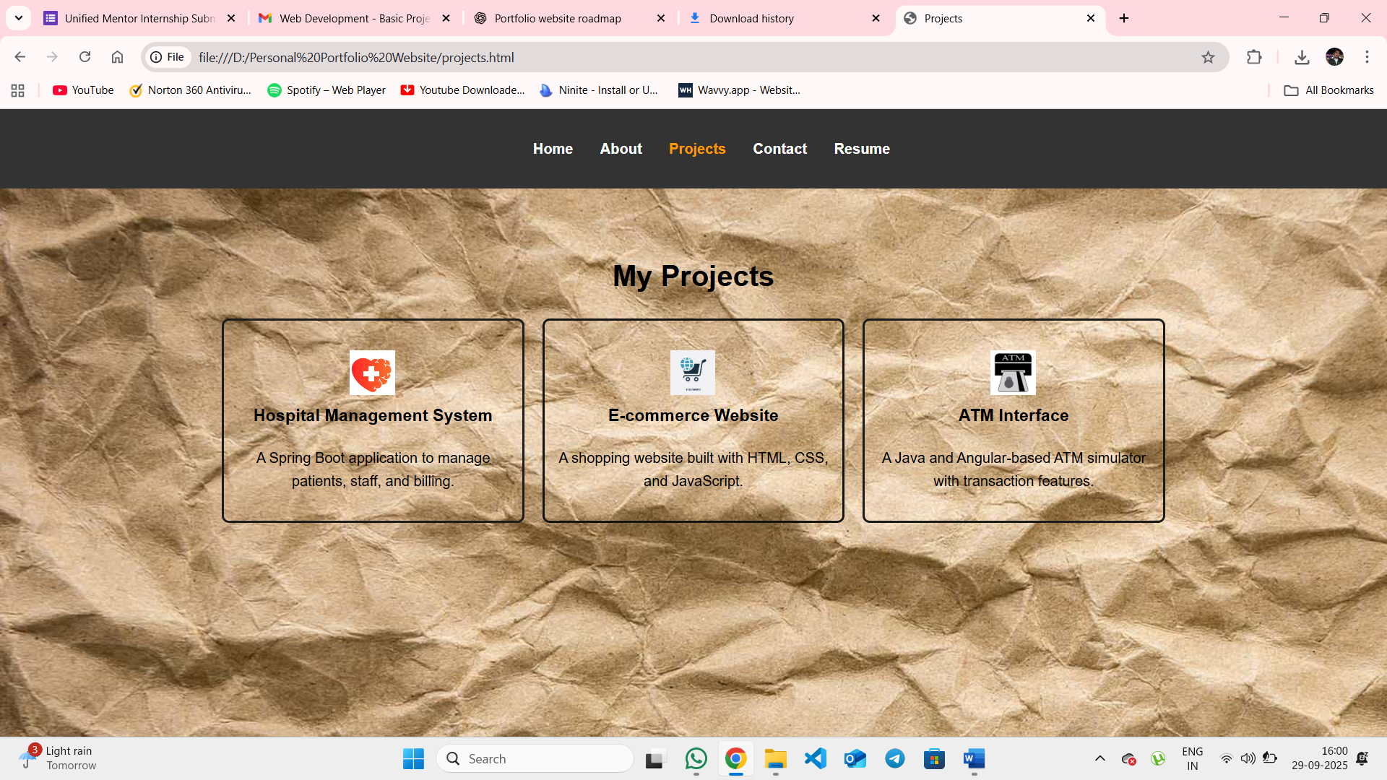

Projects Page: Displays project titles, descriptions, and images.

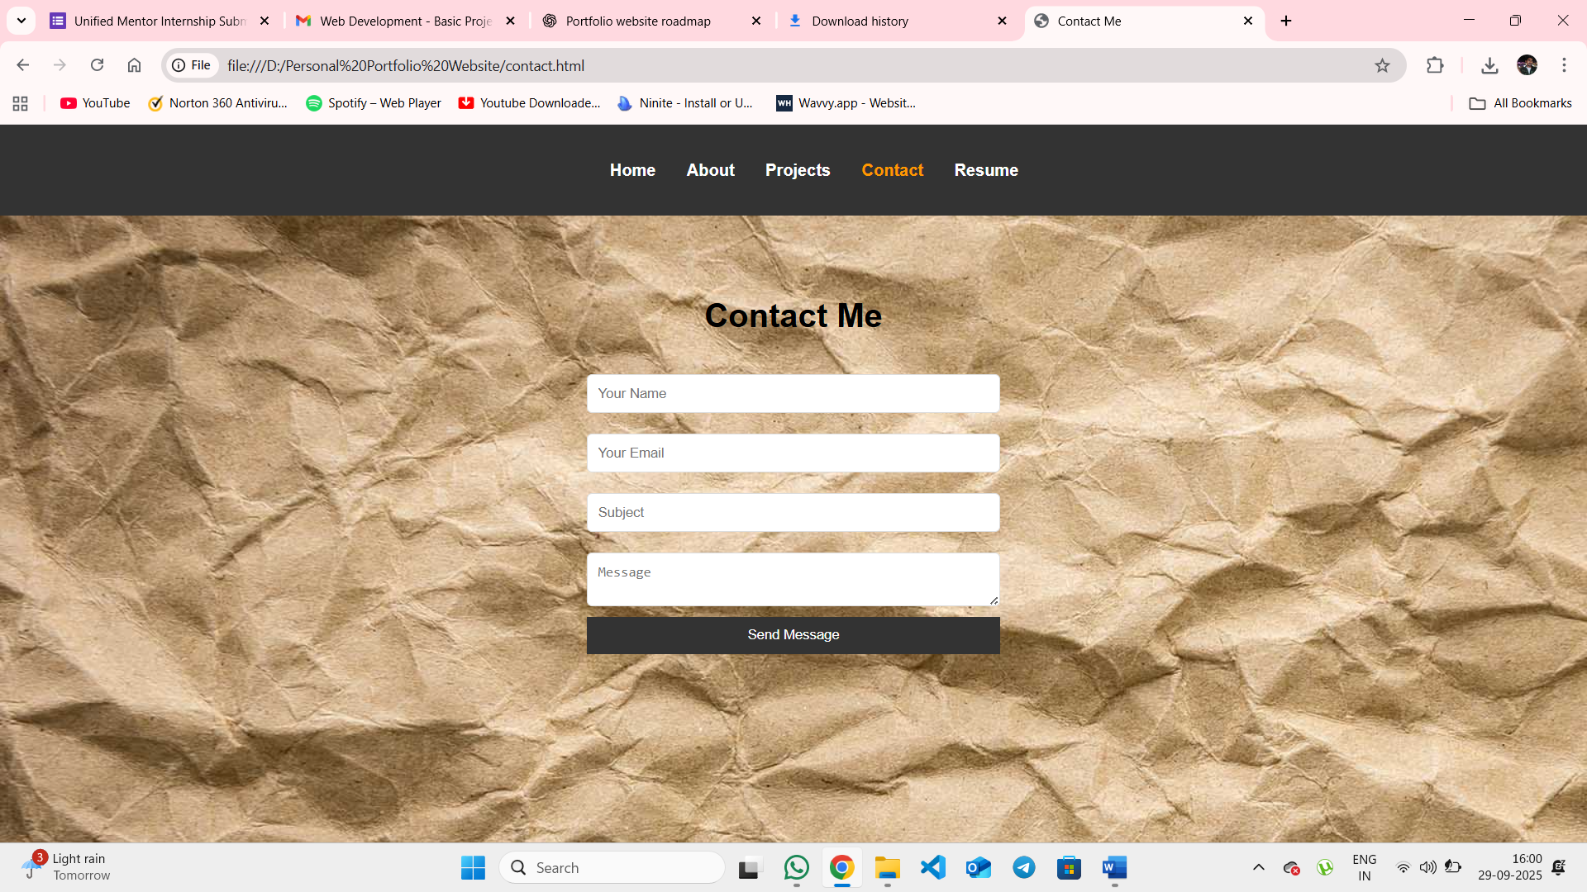

Contact Page: Contains a contact form with JavaScript validation.

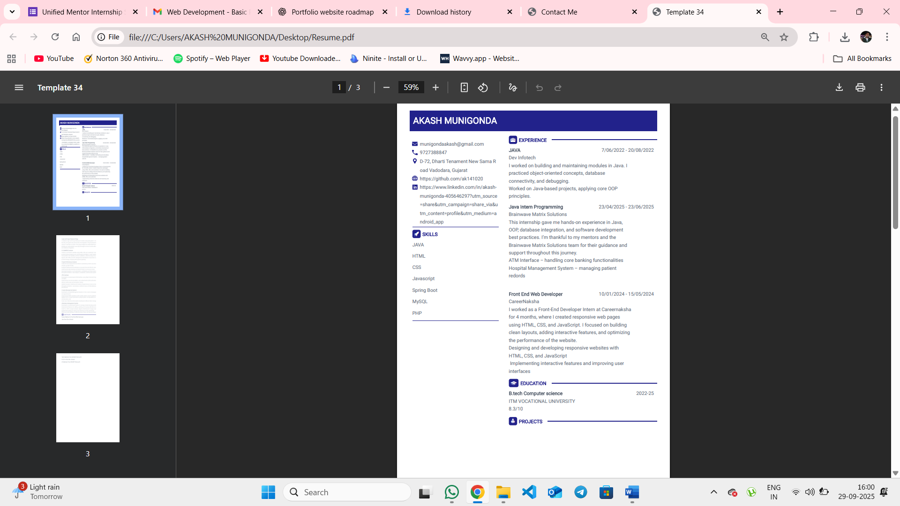

Resume: contains all the data

## Project Structure

The project directory contains the following files and folders:  
  
portfolio-website/  
│── index.html (Home Page)  
│── about.html (About Page)  
│── projects.html (Projects Page)  
│── contact.html (Contact Page)  
│── style.css (Global CSS)  
│── script.js (JavaScript interactivity)  
│── resume.pdf (Resume file)  
│── images/ (Profile & project images)

## Design & Implementation

1. Home Page: Introduces the user with a profile picture, name, and short description.  
2. About Page: Provides background information including education and hobbies.  
3. Projects Page: Displays a gallery of project cards with images and descriptions.  
4. Contact Page: Contains a form with JavaScript validation to send messages.  
5. CSS: Ensures consistent styling, hover effects, responsive layout, and typography.  
6. JavaScript: Validates form input and adds interactivity.

## Key Features

* Responsive design with media queries for multiple devices.
* Navigation bar with active link highlighting.
* Hover effects on project cards and buttons.
* Contact form validation using JavaScript.
* Downloadable resume link.
* Project gallery with interactive design.

## Conclusion

The Personal Portfolio Website successfully showcases the individual's skills, projects, and resume in an interactive and professional manner. It demonstrates practical knowledge of web development using HTML, CSS, and JavaScript while emphasizing responsive design and interactivity.